Product Frequently Asked Question Extension

**Author:**

Vladan Kuzmanovic

[vladankuzmanovic@gmail.com](mailto:vladankuzmanovic@gmail.com)

**Features**:

* *Add question form on PDP page to allow customer to ask questions related to the product*
* *Adds list of the Frequently Asked Questions on the PDP page (accordion)*
* *Allows site administrator to create Question Groups*
* *Allows site administrator to easily answer and approve questions and assign them to Question Group.*
* *Allows site administrator to create new questions and assign them to Question Group.*
* *Supports multiple stores*

**User Guide**

Frontend:

***Note****: To be able to see changes on frontend you might need to clear the cache after modifications*

1. Customer can easily ask a questions

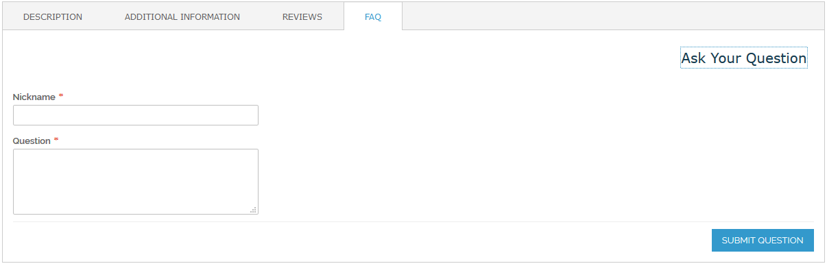

1. The question Groups with question are shown as accordion

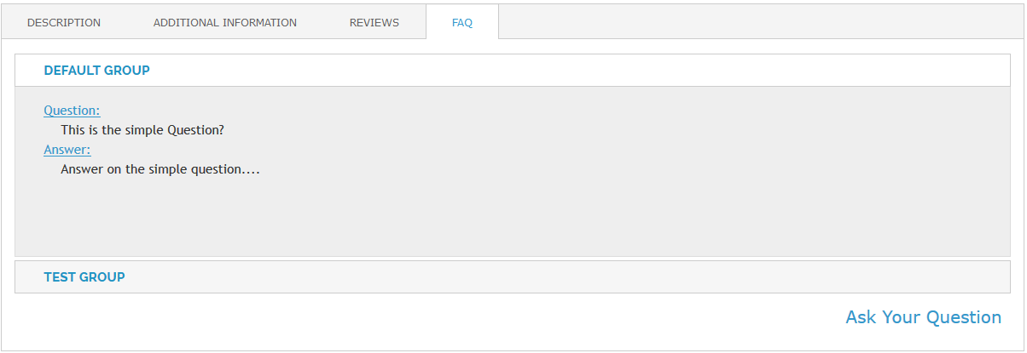

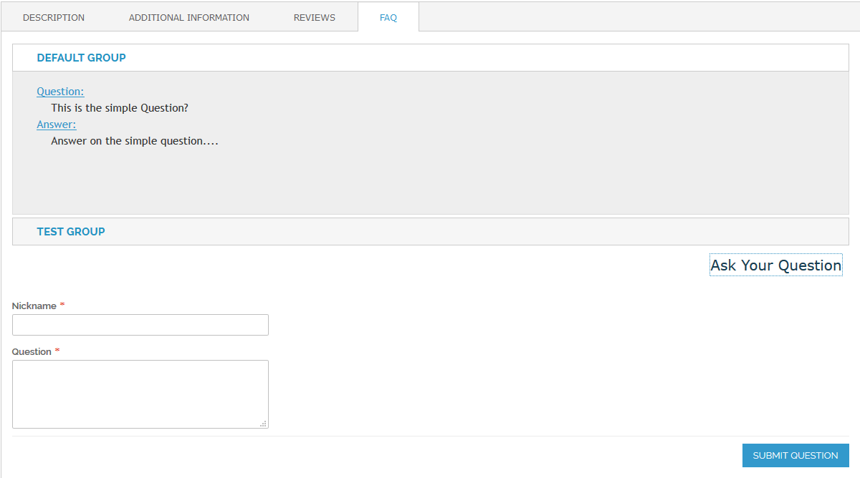

BackOffice

1. General Configuration

Enable / Disable FAQ (supported on store view level)

System > Configuration > KUZMAN MODULES > Products FAQ > General > Enabled

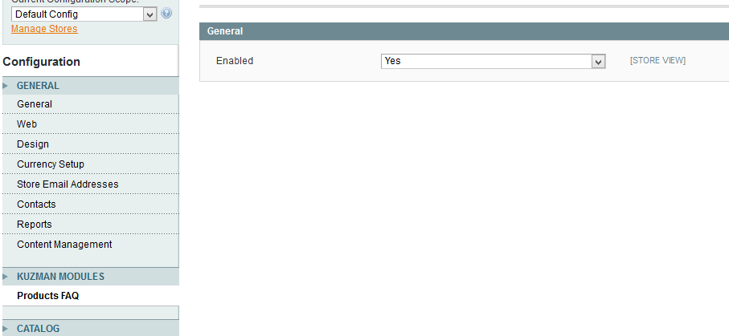

1. Question Groups Administration

Catalog > Product FAQ > Manage Question Groups

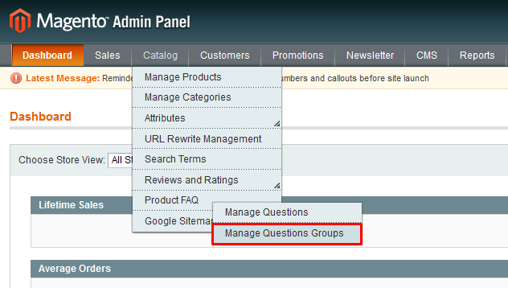

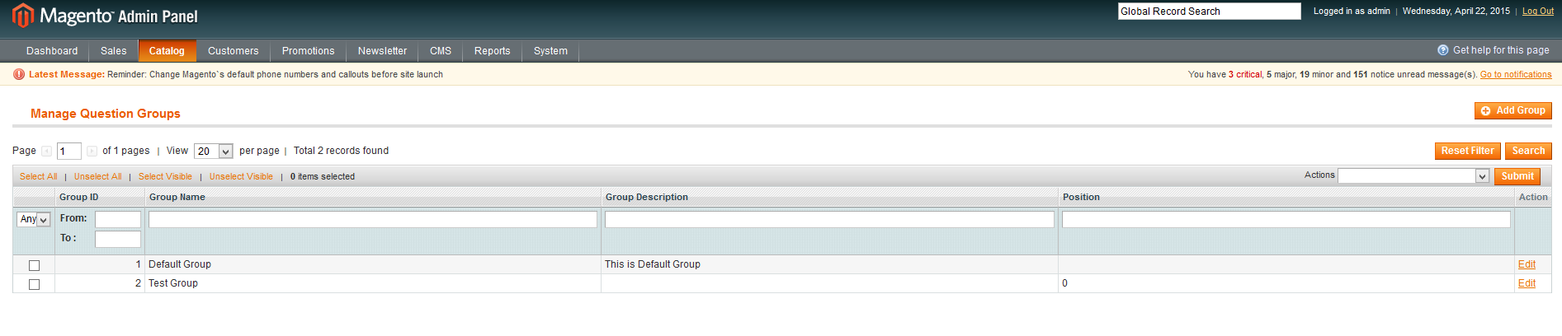

* Adding New Group

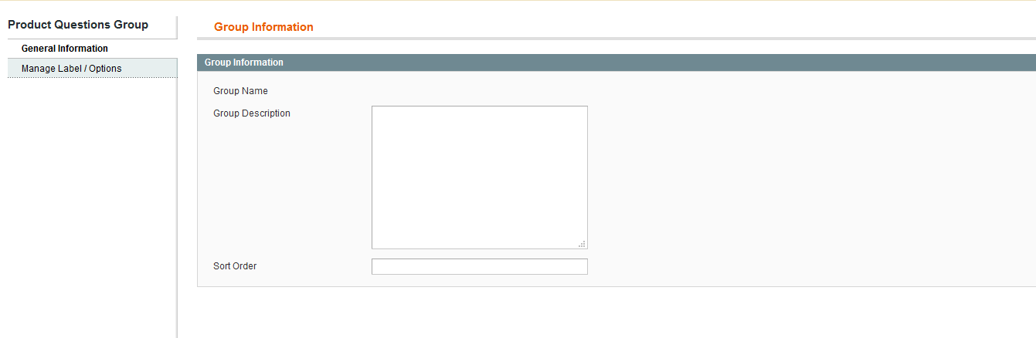

Fields:

*General Information Tab*

* **Group Name** – Default Group name – Empty before first Save (after takes value from Admin labels)
* **Group Description**
* **Sort Order** – Sorting the question Groups on Frontend

*Manage Label / Options Tab*

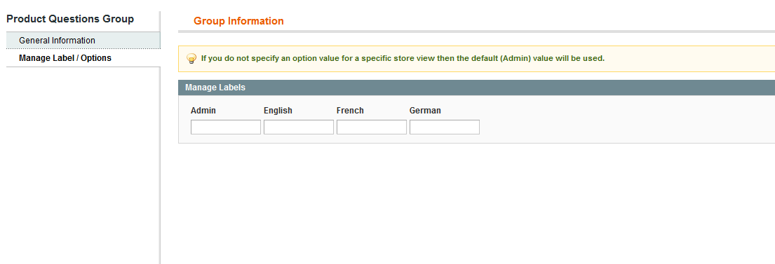

1. Questions Administration

Catalog > Product FAQ > Manage Question Groups

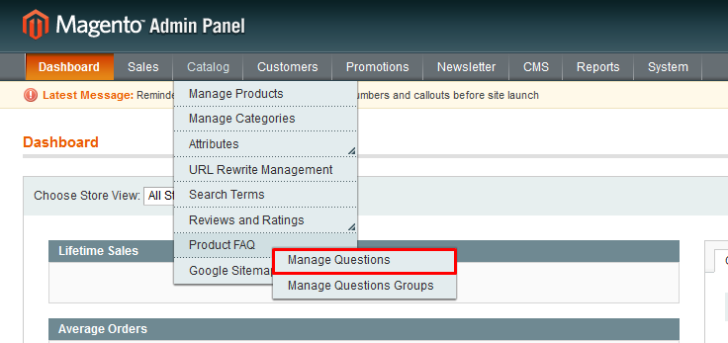

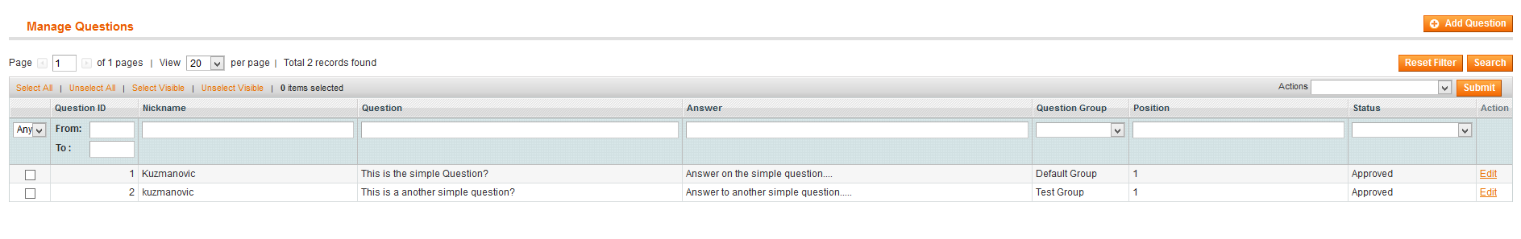

* Add new Question to FAQ list

*General Information Tab*

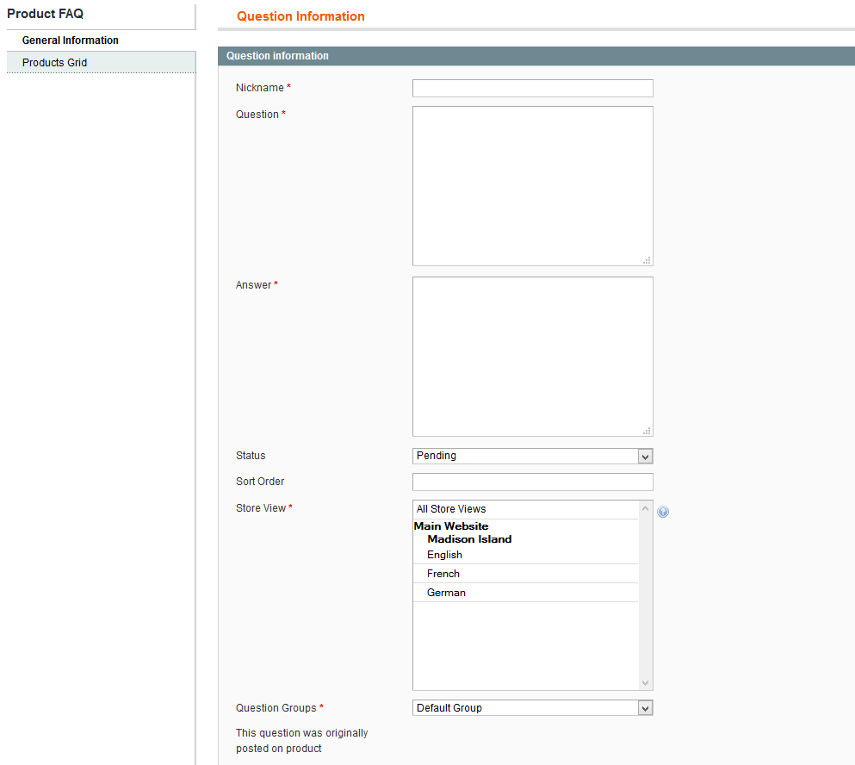

Fields:

* **Nickname**
* **Question**
* **Answer**
* **Status** – Possible options are Pending and Approved (if approved question will be shown on assigned product PDP)
* **Sort Order** – Sorting the question inside the selected question group
* **Store View** – Chose the store where the question will be visible.
* **Question Group** – Chose the group for which question will be assigned
* **The question was originally posted on product** – empty if question was created from admin

*Products Grid Tab*

* Chose Product for which you want question to be assigned

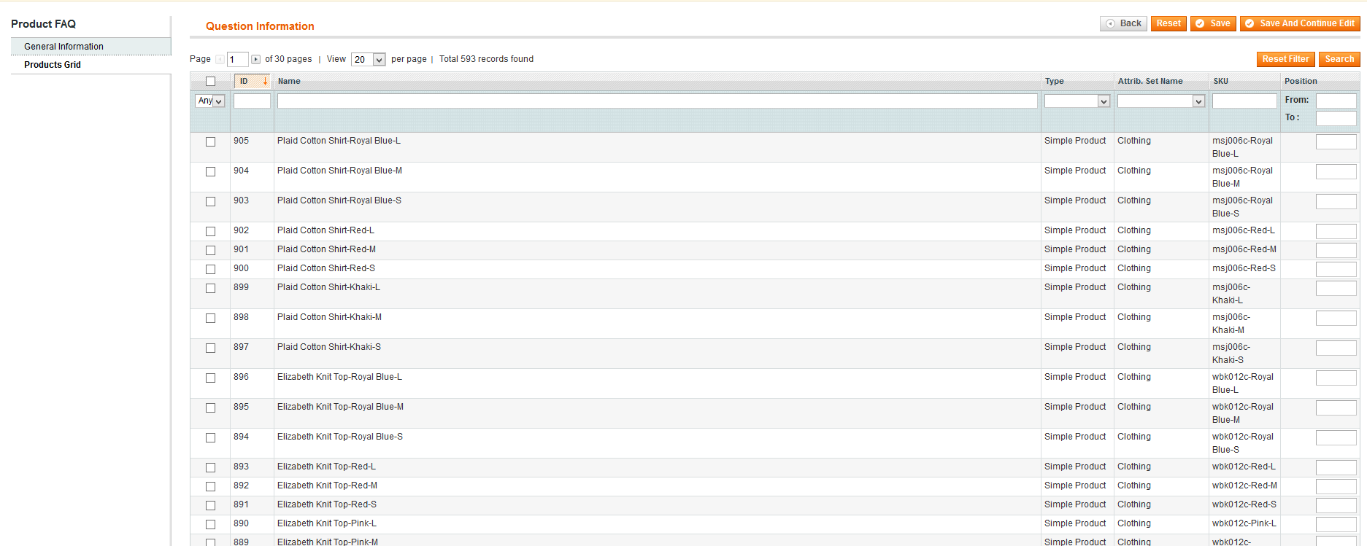

* Add new Question to FAQ list

*General Information Tab*

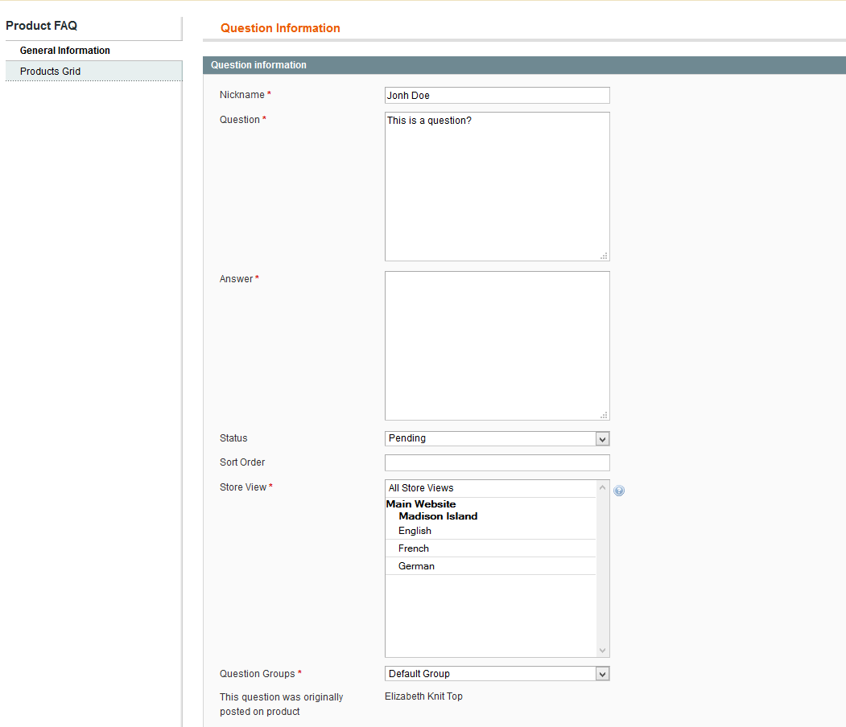

Fields:

* **Nickname** -Populated
* **Question** -Populated
* **Answer**
* **Status** – Possible options are Pending and Approved (if approved question will be shown on assigned product PDP)
* **Sort Order** – Sorting the question inside the selected question group
* **Store View** – Chose the store where the question will be visible.
* **Question Group** – Chose the group for which question will be assigned
* **The question was originally posted on product** – the name of the product where the question was posted

*Products Grid Tab*

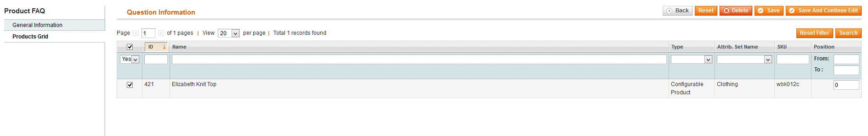

* Product where question was originally posted is marked (it is possible that administrator mark another products where wants question to be shown)